Inviting turtles to Lunch
Blueberries: Plant an Extra Bush!
Last month we talked about how Box Turtles were once used in Gardens to keep garden pests under control. We also talked about building hide-a-ways or stick debris piles for turtles to hide in and find food that lives among the decomposing leaves and sticks.
As Omnivores,Box Turtles need more than just some worms and slugs and have survived for millions of years eating whatever they came across. As climates settled and became consistent, plants evolved in different habitats creating reliable food sources which helped our Eastern Box turtle become the recognizable turtle that we know today.
One plant that evolved with our Eastern Box Turtles in the wooded under-story, and was once as wild and native as the turtles themselves is the Blueberry.
There are a few native varieties of Blueberries that can still be found in scattered patches of old growth woods, around central Virginia, but the good news is that all varieties of cultivated Blueberries have been created from these wild bushes and do well in our slightly acidic soil

Blueberries are considered to be a super food. They provide Fiber, and are a good source of vitamin K1, vitamin C and manganese, along with vitamins E, B6 and copper. Blueberries are rich in antioxidants and may help lower blood pressure , and delay age related brain decline. Blueberries also may lower blood sugar and improve insulin sensitivity. Adverse effects or allergies are very rare.

With all this going for them it is a wonder that we all don't have Blueberries growing in our backyards. Perhaps the long term relationship with blueberries that our native box turtles have, has helped them develop the long life terms they are known for, and the extreme ability to eat just about anything.

Anyway you look at it, Blueberries are good for us and they are good for wildlife. Box Turtles are not the only critters that you will see enjoying this sunny summer fruit. Blueberries are a favorite among song birds, small rodents, foxes, and deer to name a few.

And Blueberries are easy to grow. Blueberry Growers in the northeast say "if you can grow pines and cedars, You can grow blueberries" Evidently, the acidic soil that is enjoyed by these native trees is also enjoyed by blueberries. Coffee Grounds can be occasionally placed around the base of Blueberry plants and acts as an inexpensive fertilizer, giving the plants a boost.

If you are into companion planting, Strawberries grow well at the base of Blueberry bushes, benefiting from the scattered shade of the bush while protecting its roots and holding in moisture.

Technically, Blueberry bushes are self pollinating and produce both male and female flowers, but it is recommended to plant more than one variety for larger fruit , and don't forget to add an extra bush or two for the turtles and the wildlife.

Where can you get Blueberry bushes for your yard and garden?
You can find Blueberry bushes at most plant nurseries, but you can also come by and visit the Box Turtle Sanctuary at Ashland Strawberry Festival on June the 16th on the campus of Randolph Macon College in Ashland VA. We are looking forward to having an educational booth with turtles, art and Blueberries! Please come by and Visit.!

(If you have cedars and pines you have appropriate soil). Coffee grounds occasionally placed around the base of your Blueberry plants will work as an inexpensive fertilizer, increasing the acidity and giving the plants a boost.

Inviting turtles to visit your yard can be an rewarding and memorable experience.
Last month we talked about how Box Turtles were once used in Gardens to keep garden pests under control. We also talked about building hide-a-ways or stick debris piles for turtles to hide in and find food that lives among the decomposing leaves and sticks.
Two questions arose from our last newsletter;
- What can I plant that will look nice in my yard / Garden and benefit us and the turtles?
- What about the unwanted visitors that may also visit my stick pile looking for food; namely Snakes?

As Omnivores, turtles survived for millions of years eating whatever they came across. As climates settled and became consistent, plants evolved in different habitats creating reliable food sources which helped our Eastern Box turtle become the recognizable turtle that we know today.

One plant that has evolved with our Eastern Box Turtles, and was once as wild and native as the turtles themselves is the Blueberry. Here are some interesting facts about blueberries that everyone should know:

How to Create a Turtle Hide-a-way with your yard Debris
Mother Winter often leaves our yards littered with offerings from the trees. So far this winter at the sanctuary, we have lost a few small trees and shrubs due to Ice and snow damage, and although it is messy and time consuming to clean up and replant, winter damage is a natural and beneficial process for both the plants and the critters that use them for shelter and food. Cold Weather damage to plants have two basic causes:
- native plants have gotten weak from insects, disease or to much fast growth.
- non-native plants are not prepared for our winter.
Although February weather is not conducive to replacing damaged winter plants, it is a good time to clean up the debris, and begin planning native alternatives for wildlife in your yard.
Here's What you can do Now
- Locate an area along the border, in the tree line, or in a corner of your yard where you can build and leave a pile of your yard debris.
- Create a pile of sticks and branches and intersperse with leaves, soil, and compost,
- DO NOT USE soil with additives like fertilizers and weed controllers, and do not place any non-native invasive plants that may root or seed into your pile.

Here's What you can expect
- Moisture in the leaves will attract insects which will begin decomposition, creating warmth.
- Sticks and branches will begin to rot as they are consumed by moisture and insects, your pile will begin to shrink.
- Insect eating birds, reptiles and amphibians will begin to visit your pile, eating insects, and further encouraging decomposition..
- The shelter and protection from predators and the elements that is created by your pile of debris will keep your new wildlife visitors returning, and create a new hot-spot of wildlife diversity for you to enjoy.

Edit

Box Turtle Sanctuary of Central Virginia

Helping You Make Your Yard Turtle Friendly
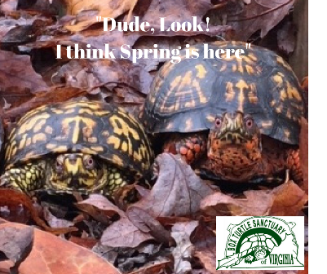

Edit  Inviting turtles to Lunch  Blueberries: Plant an Extra Bush!  As Omnivores, Box Turtles need more than just some worms and slugs and have survived for millions of years eating whatever they came across. As climates settled and became consistent, plants evolved in different habitats creating reliable food sources which helped our Eastern Box turtle become the recognizable turtle that we know today.  One plant that evolved with our Eastern Box Turtles in the wooded under-story, and was once as wild and native as the turtles themselves is the Blueberry.  There are a few native varieties of Blueberries that can still be found in scattered patches of old growth woods, around central Virginia, but the good news is that all varieties of cultivated Blueberries have been created from these wild bushes and do well in our slightly acidic soil.  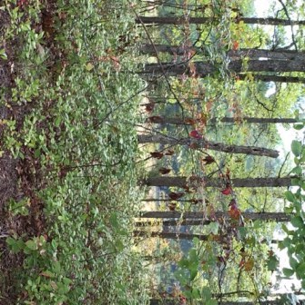wild native blueberries grow in large root masses under the canopy of native trees  Blueberries are considered to be a super food. They provide Fiber, and are a good source of vitamin K1, vitamin C and manganese, along with vitamins E, B6 and copper. Blueberries are rich in antioxidants and may help lower blood pressure , and delay age related brain decline. Blueberries also may lower blood sugar and improve insulin sensitivity, and adverse effects or allergies are very rare.  With all this going for them it is a wonder that we all don't have Blueberries growing in our backyards.Perhaps the long term relationship with blueberries that our native box turtles have, has helped them develop the long lives and the extreme ability to eat just about anything.  Anyway you look at it, Blueberries are good for us and they are good for wildlife. Box Turtles are not the only critters that you will see enjoying this sunny summer fruit. Blueberries are a favorite among song birds, small rodents, foxes, and deer to name a few.  And Blueberries are easy to grow. Blueberry Growers in the northeast say "if you can grow pines and cedars, You can grow blueberries" Evidently, the acidic soil that is enjoyed by these native trees is also enjoyed by blueberries.Coffee grounds can be occasionally placed around the base of Blueberry plants and acts as an inexpensive fertilizer, giving the plants a boost.  If you are into companion planting, Strawberries grow well at the base of Blueberry bushes, benefiting from the scattered shade of the bush while protecting its roots and holding in moisture.  Technically, Blueberry bushes are self pollinating and produce both male and female flowers, but it is recommended to plant more than one variety for larger fruit, and don't forget to add an extra bush or two for the turtles and the wildlife.  Where can you get Blueberry bushes for your yard and garden?  You can find Blueberry bushes at most plant nurseries, but you can also come by and visit the Box Turtle Sanctuary at The Ashland Strawberry Festival on June the 16th on the campus of Randolph Macon College in Ashland VA.We are looking forward to having an educational booth with turtles, art and Blueberries! Please come by and Visit and get a Blueberry bush or two for your wildlife!  Add | Edit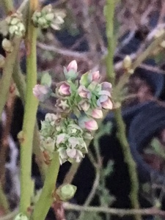

Edit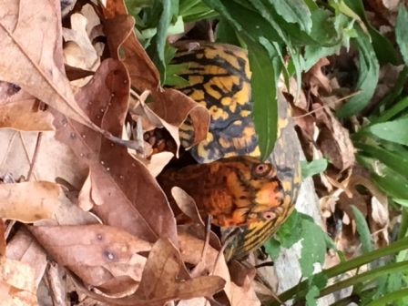  Edit  Add | Edit  Edit  The Box Turtle Sanctuary will have a booth at  The Ashland Strawberry Faire  on June 16, 2018.  We will have an educational display with live native turtles, with a special guest :  Sully and African Sulcata.  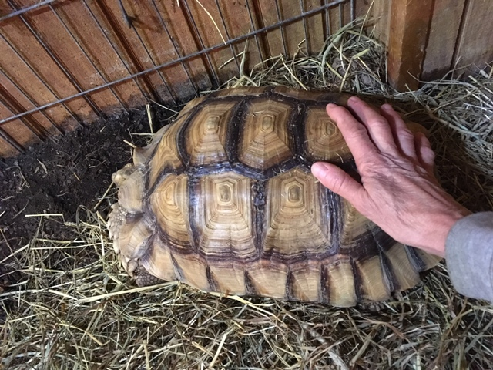  We will also have eARTh Art activities for children of all ages, and don't forget to stop by to pick up some blueberry bushes  Educational Programs are still available!  Book Yours Today!  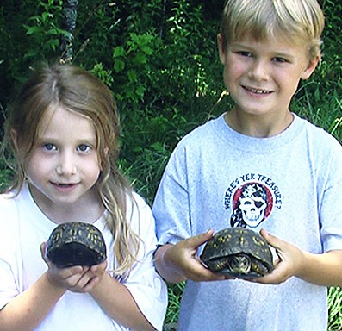  Educational Opportunities  for 2018  As an Advocate for Turtles, Educational programs are created around their schedule..  Programs are limited!  Book Yours Today!  Turtle Parties are a  Great Educational  Ohh and Ahhh Moment for Kids of All Ages!  *NEW for 2018  Turtles from around the World!  Meet Sully!  Learn about turtles and their Habitats!  How their shell can help you tell where they live and what they eat!  All Boxed In  Explore a year in the life of An Eastern Box Turtle. Discover how they survived the days of the dinosaurs and became one of Virginia oldest residents. And Learn how you can encourage these ancient reptiles to visit your yard and keep them coming back.  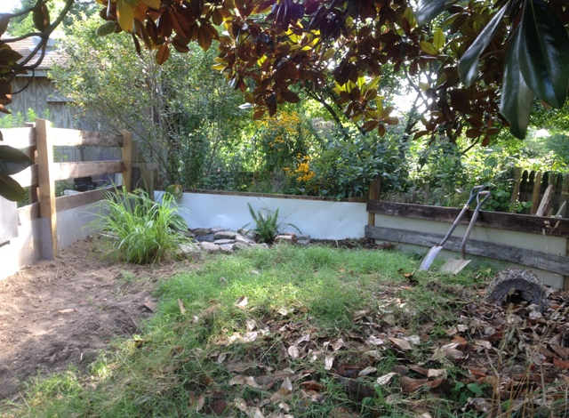  We Are Growing and need your help.  With the recent help from U of R School of Law, we are ready to expand our board and are looking for community involvement. If you or someone you know has a love for turtles, our natural world and sharing this knowledge and are interested in making a difference in our neighborhood, We would love to talk!  Please drop me an e-mail

Edit  Inviting turtles to Lunch  Blueberries: Plant an Extra Bush!  As Omnivores, Box Turtles need more than just some worms and slugs and have survived for millions of years eating whatever they came across. As climates settled and became consistent, plants evolved in different habitats creating reliable food sources which helped our Eastern Box turtle become the recognizable turtle that we know today.  One plant that evolved with our Eastern Box Turtles in the wooded under-story, and was once as wild and native as the turtles themselves is the Blueberry.  There are a few native varieties of Blueberries that can still be found in scattered patches of old growth woods, around central Virginia, but the good news is that all varieties of cultivated Blueberries have been created from these wild bushes and do well in our slightly acidic soil.  wild native blueberries grow in large root masses under the canopy of native trees  Blueberries are considered to be a super food. They provide Fiber, and are a good source of vitamin K1, vitamin C and manganese, along with vitamins E, B6 and copper. Blueberries are rich in antioxidants and may help lower blood pressure , and delay age related brain decline. Blueberries also may lower blood sugar and improve insulin sensitivity, and, adverse effects or allergies are very rare.  With all this going for them it is a wonder that we all don't have Blueberries growing in our backyards.Perhaps the long term relationship with blueberries that our native box turtles have, has helped them develop the long lives and the extreme ability to eat just about anything.  Anyway you look at it, Blueberries are good for us and they are good for wildlife. Box Turtles are not the only critters that enjoy this sunny summer fruit. Blueberries are a favorite among song birds, small rodents, foxes, and deer to name a few.  And Blueberries are easy to grow. Blueberry Growers in the northeast say "if you can grow pines and cedars, You can grow blueberries" Evidently, the acidic soil that is enjoyed by these native trees is also enjoyed by blueberries.Coffee grounds can be occasionally placed around the base of Blueberry plants and acts as an inexpensive fertilizer, giving the plants a boost.  If you are into companion planting, Strawberries grow well at the base of Blueberry bushes, benefiting from the scattered shade of the bush while protecting its roots and holding in moisture, and, strawberries are also loved by our native box turtles.  Technically, Blueberry bushes are self pollinating and produce both male and female flowers, but it is recommended to plant more than one variety for larger fruit, and don't forget to add an extra bush or two for the turtles and the wildlife.  Where can you get Blueberry bushes for your yard and garden?  You can find Blueberry bushes at most plant nurseries, but you can also come by and visit the Box Turtle Sanctuary at The Ashland Strawberry Festival on June the 16th on the campus of Randolph Macon College in Ashland VA.We are looking forward to having an educational booth with turtles, art and Blueberries! Please come by and Visit and get a Blueberry bush or two for your wildlife!  Add | Edit

Edit  Edit  Help Support The Box Turtle Sanctuary every time you shop at Kroger.  Did you know you can support The Box Turtle Sanctuary just by shopping at Kroger? It's easy when you enroll in Kroger Community Rewards®! Just sign up with your Plus Card, and select the Box Turtle Sanctuary of Virginia. Once you're enrolled, you'll earn rewards every time you shop and use your Plus Card, and earn fuel points for yourself  Enroll now for the Kroger Community Rewards Program. And remember…all participants must re-enroll each year to continue earning rewards for their chosen organization.  We Are Growing and need your help.  With the recent help from U of R School of Law, we are ready to expand our board and are looking for community involvement. If you or someone you know has a love for turtles, our natural world and sharing this knowledge and are interested in making a difference in your neighborhood, We would love to talk!  Please drop me an e-mail at art4turtles@gmail.com  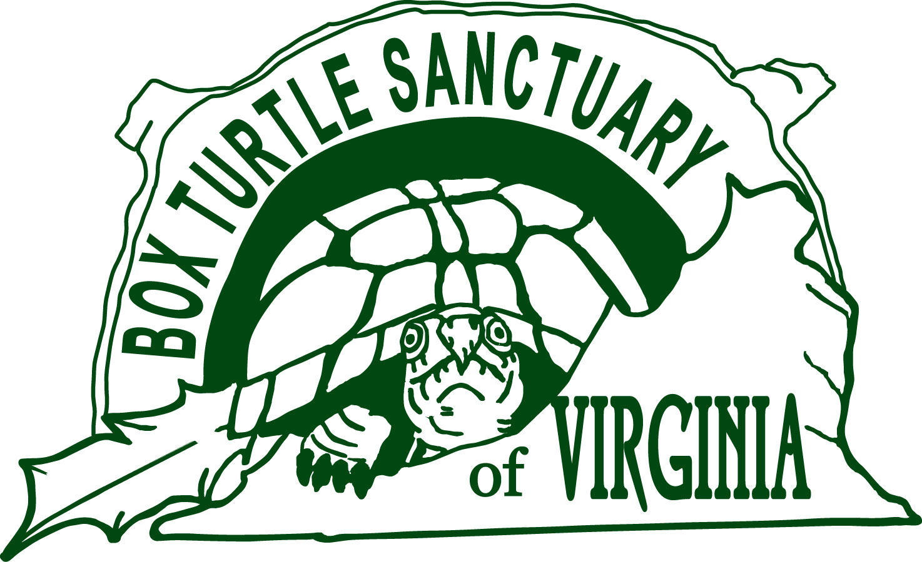  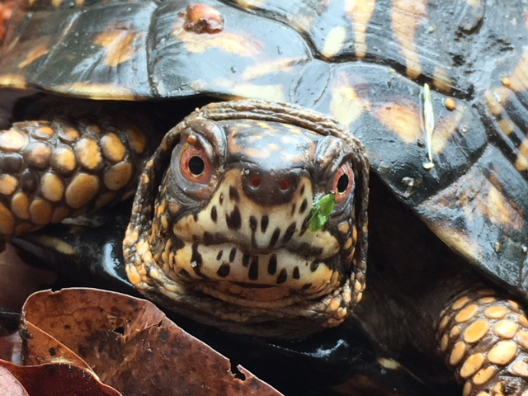  All Boxed In  Meet some native box turtles and some shelled friends!  Explore a year in the life of An Eastern Box Turtle. Discover how they survived the days of the dinosaurs and became one of Virginia oldest residents. And Learn how you can encourage these ancient reptiles to visit your yard and keep them coming back.  Add | Edit  Edit  Come visit the Box Turtle Sanctuary at the  The Ashland Strawberry Faire  on June 16, 2018.  We will have an educational display with live native turtles, with a special guest :  Sully the African Sulcata.  Look for us at RMC  Welcome Center  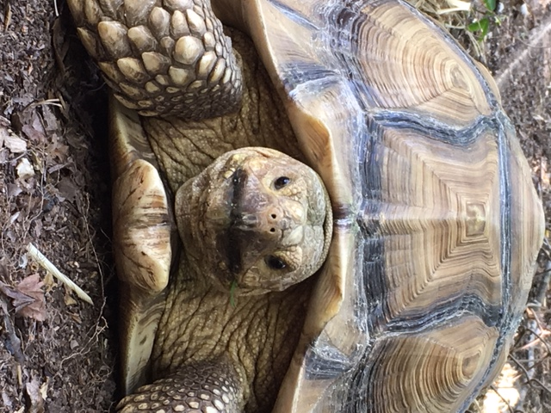  We will also have eARTh Art activities for children of all ages, and don't forget to stop by to pick up some blueberry bushes  Educational Programs are still available for 2018  Book Yours Today!  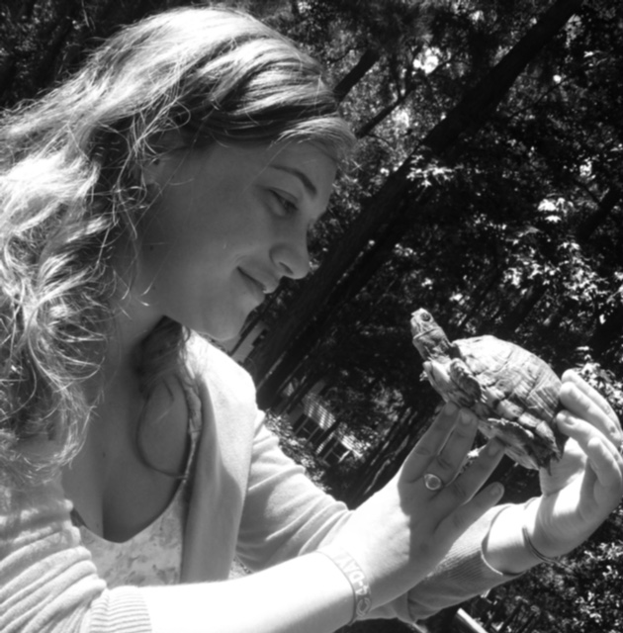  Turtle Parties are a great Educational Ohh and Ahhh Moment for Kids of All Ages!  As an Advocate for Turtles, Educational programs are created around their schedule..  Programs are limited!  Book Yours Today!  *NEW for 2018  Turtles from around the World!  Meet Sully!  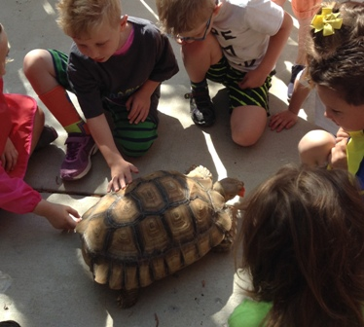  Learn about turtles and their Habitats!  How their shell can help you tell where they live and what they eat!

